AI statement:
In these bonus questions, I used AI tools (Gemini) as a learning assistant. Specifically, I used AI to:
1. Help me better understand the questions requirements.
2. Get suggestions on which points to choose
3. Optimize my written text answers for better clarity.

Bonus Question (a)
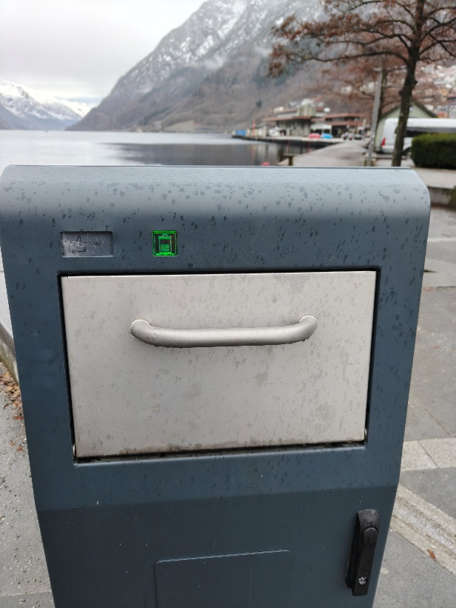
ANSWER: To align the two images, we must focus on a planar surface (the front face of the trash can). Mapping one plane to another across different camera views requires a projective transformation (homography).
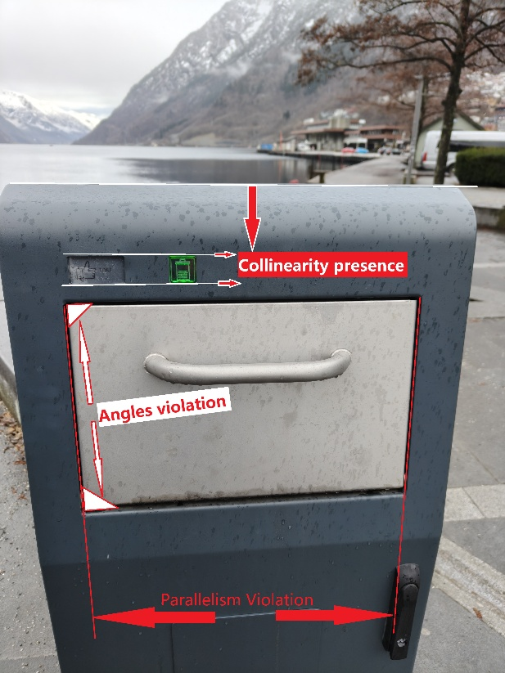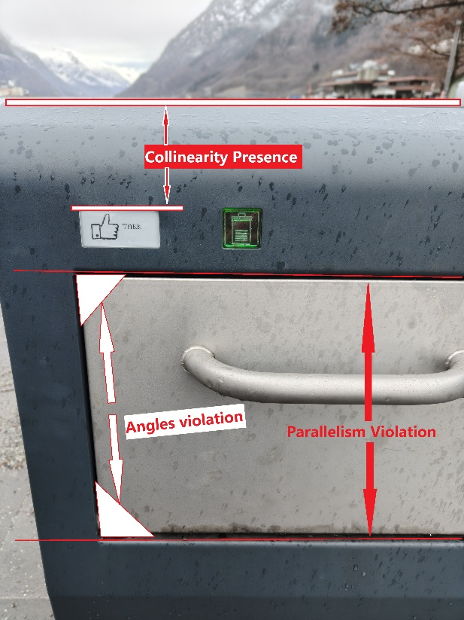
Parallelism (Affine Invariance): The left and right vertical edges of the metal flap are parallel. However, due to the change in the camera's viewpoint, these lines converge towards a vanishing point in the images. Because parallelism is not preserved, an Affine transformation (which preserves parallel lines) is insufficient.
Angles (Similarity Invariance): The metal flap is a rectangle in reality, meaning its corners are exactly 90 degrees. In the captured images, perspective distortion skews these shapes, and the corners are no longer 90 degrees. Because angles are not preserved, a Similarity transformation (which preserves angles) is insufficient.
Collinearity (Projective Invariance): A Projective transformation preserves straight lines. The physical edges of the metal flap and the rectangular sticker are straight in the real world. Despite the severe perspective distortion between the two camera views, these edges remain perfectly straight lines in the 2D images.

Bonus Question (b)
ANSWER: No, these residuals can’t be consistent with a model produced from a minimal sample for the projective transformation (homography).
Projective transformation has 8 degrees of freedom. Each point correspondence provides 2 constraints. Therefore, the minimal solver for a projective transformation requires a minimal sample of 4 point correspondences. To be consistent with a projective transformation minimal solver, the given list of 5 residuals must contain 4 residuals of (0.00, 0.00).
To make the conclusion becomes the opposite. I would modify three of the non-zero residuals(r1, r2, r4) to become zero.
• r1 = (0.00, 0.00)
• r2 = (0.00, 0.00)
• r3 = (0.00, 0.00)
• r4 = (0.00, 0.00)
• r5 = (2.00, 3.04)
Then the 4 zero residuals perfectly align with the property of a 4-point minimal solver for a projective transformation.

